ENSE 271 - Group J
Team Members: Bryanna, Lei-Ann, Audrey, Mason
Presentation format
- Empathy mapping & associated problem insights
- Your team's navigation/site map ideas
- Your team's low-fidelity prototypes
- Your team's evolved USM
Project Background: EnviroCollective Network focuses on sustainability action in Regina and area. For this project, we are tasked to redesign their website in a way that promotes the programs they offer and also creates a platform where people can find specific programs, be educated and get involved with everything they have to offer.

Business need/opportunity: EnviroCollective needs a website structure in which users can easily navigate the resources they provide and book into the Repair Cafe in a way that results in complete understanding from both customers and the EnviroCollective team.

North star & carryover customers: The north star is to create a website that guides people through the process of learning about sustainability and exploring what opportunities there are to take part in more sustainable practices. The core value of this website is to expand the access to resources regarding sustainability while considering user experience, UI design, and the durability of the website in the long run. The carry over customers are the group of people who we still want to keep from the original website design and still feel comfortable using the new design

Assumptions: Use of Wordpress, usability over aesthetic/design, engaging and decorative graphics, high visibility (direct access to resources and information), a consistent colour scheme of nature theme, use of professional photos and images captured by the company itself, a landing page that promotes other nonprofit organizations, small businesses, and affiliates

Constraints: Low-fi materials, low realism, difficult to test complex ideas, limited interactivity, irregular customer check-ins, rough visuals/sketches that cannot run core user functionality.

Insights/Needs Chart/Document
Business Concern (observation + source of information)
- Lack of engaging graphics and visual concent
- Ensure blogs, stories, community writers, environmental news, and issues are being presented across different platforms
- Does not highlight volunteers, partners, affiliations, and community contributions
- Identified the functionality of the online booking as the biggest concern, regarding about volunteer availability and unavailable bookings
- Limited budget, so functionality over visuals
- Wants the website as a historical marker that tracks company progress, preserve stories, and community information
Business Impacts
- Customers have trouble navigating and access relevant resources
- Valuable resources like stories and research tools are difficult to find and obtain
- Volunteers and community contributors are being insufficiently acknowledged and recognized for their credits
- Current website is too text-heavy resulting in lower user engagement
- Client is not confident that their website does not provide important details and information for users to return to their website regularly
Proposed Solution
- Clear, simple and readable navigation that directs users easily
- Redesigned and improved online booking system that displays available services and precautionary instructions/notices before booking
- Searchable resource directory that allows users to connect to sustainable resources, valuable research findings, educational materials, and related contents
- Separate section for story and news (Pollinator) that allows guests writers and visitors to upload personal blogs, important environmental news, and community stories
- Colourful graphics and images to balance the text heaviness
- Engaging and interactive pop-ups such as donations and “get involved”
- Online booking inventory information that tracks items repaired, bookings, repair success rates, and other booking statistics
Expected Benefit
- Increase regular user website usage
- Improve community advocacy through published stories, news, and worldwide or local issues
- Improved version of the online booking to reduce booking overlaps around repair availability
- Accessibility for students, teachers, and community members to sustainable resources and tools
- Reduce user navigation difficulties
- Preserve the organization’s history, progress, and old works
- Increase volunteers, partners, businesses, and affiliates visibility
- Encourage donations and “get involved” participation
- Potential central hub for sustainability and repair

Site Maps
Bryanna:
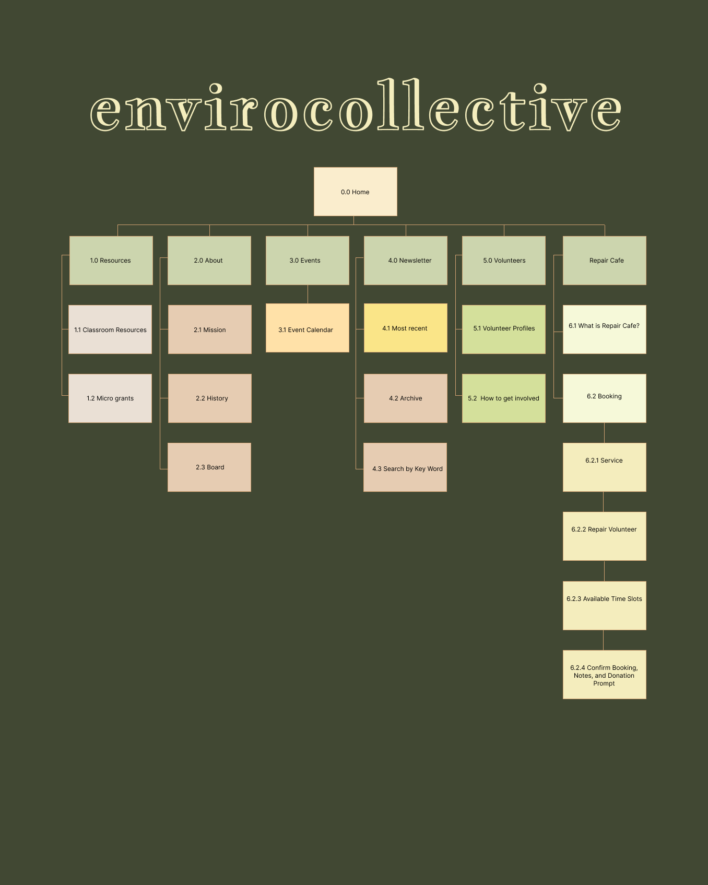

Lei-Ann:
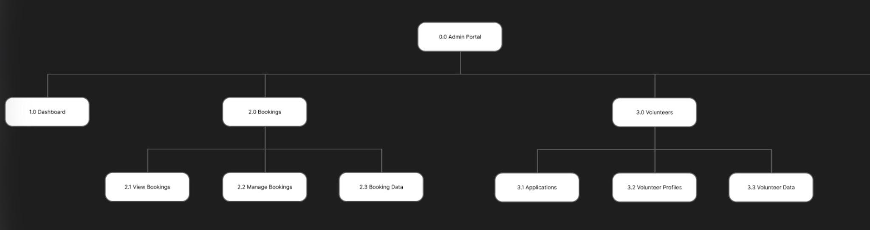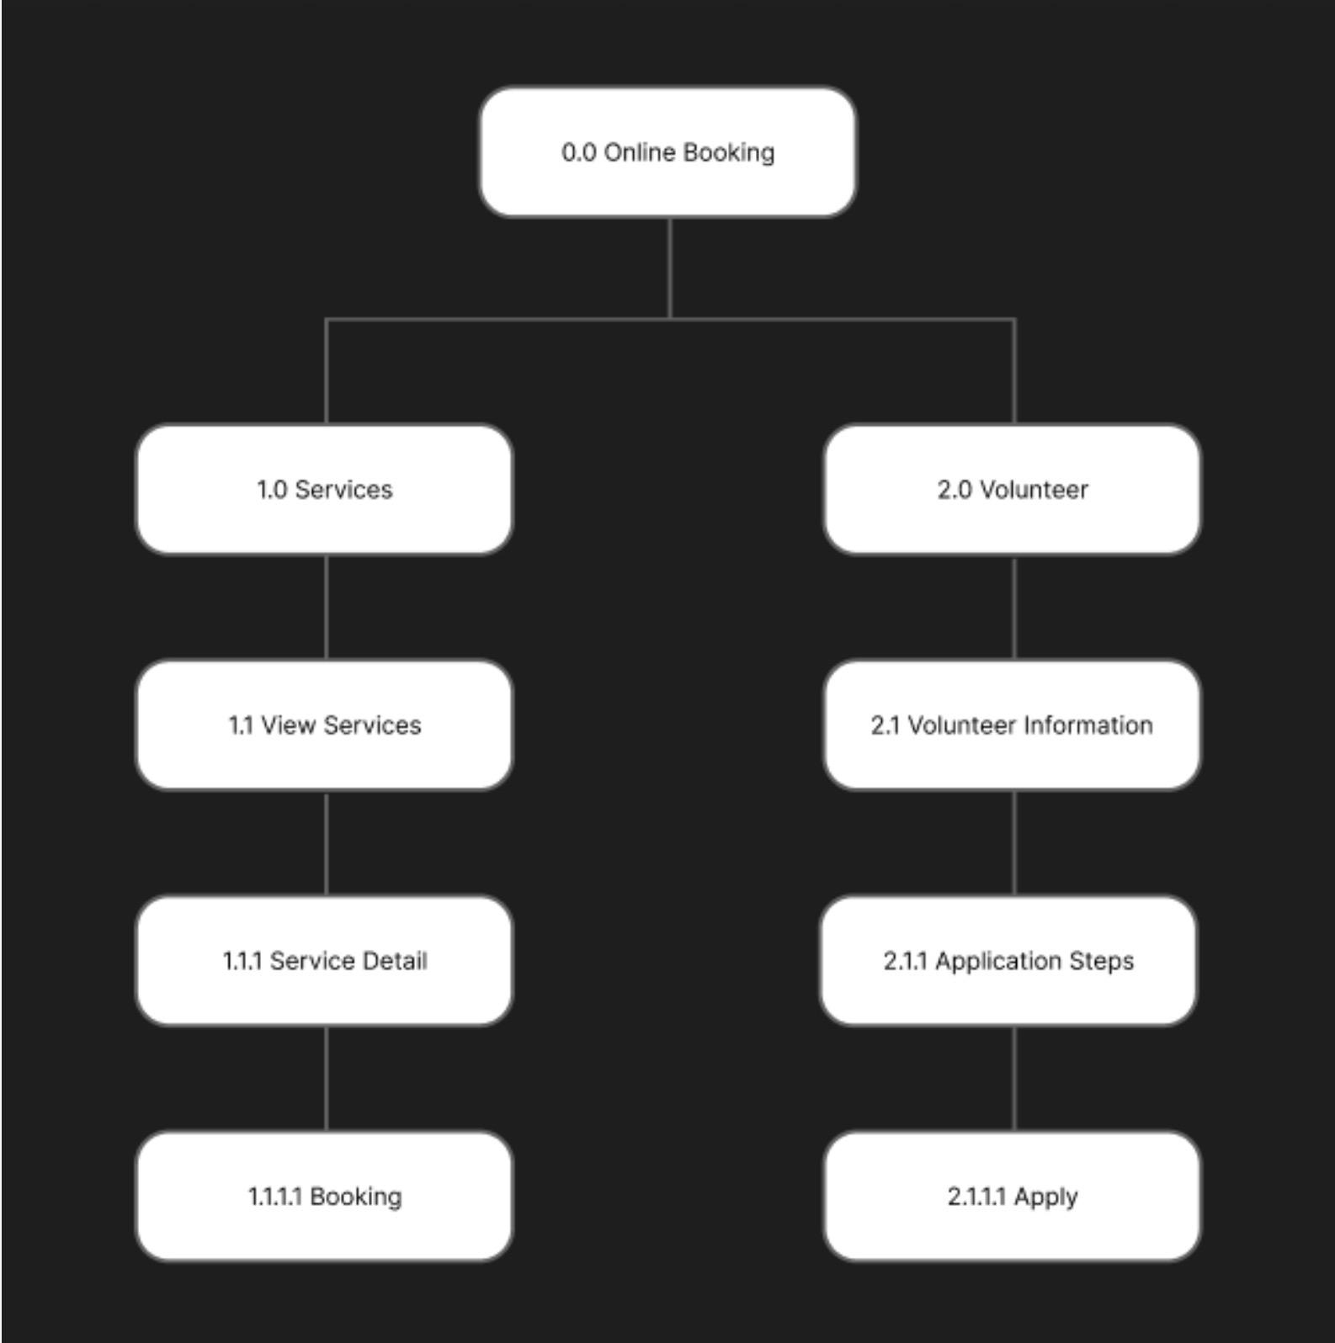

Audrey:
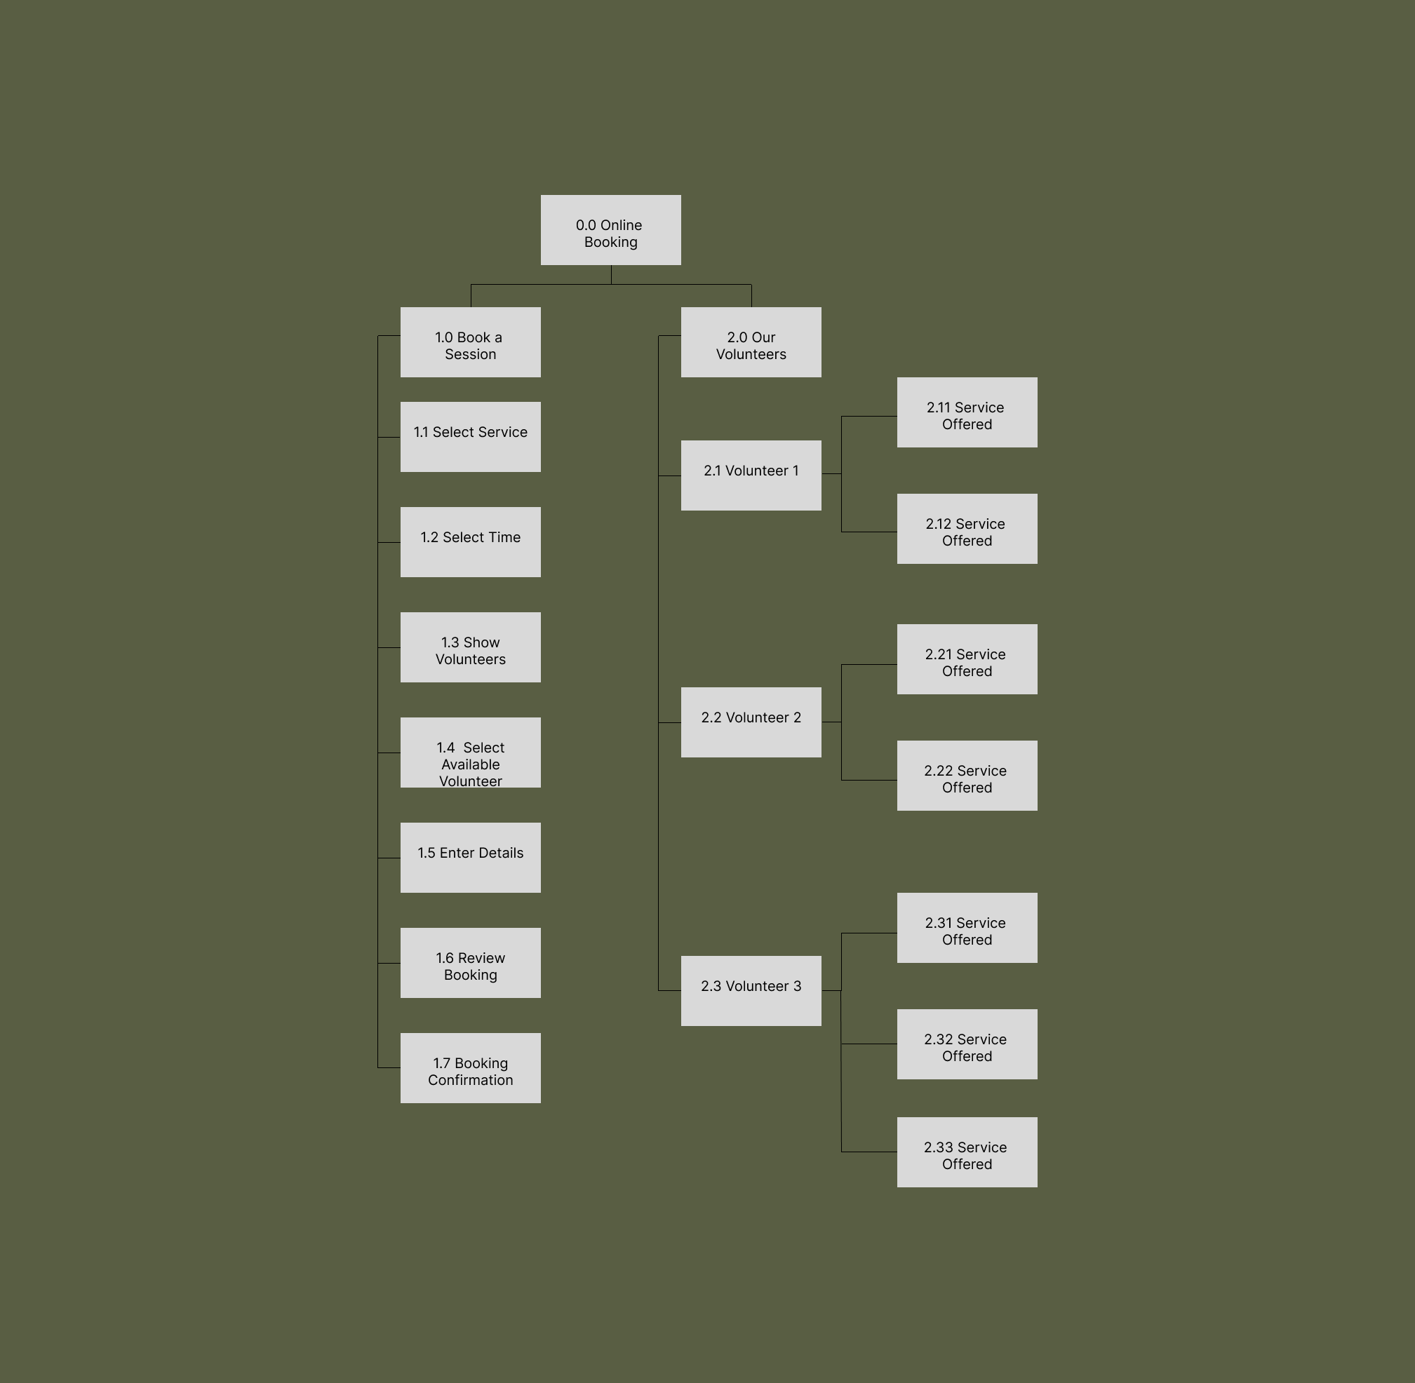
Mason:
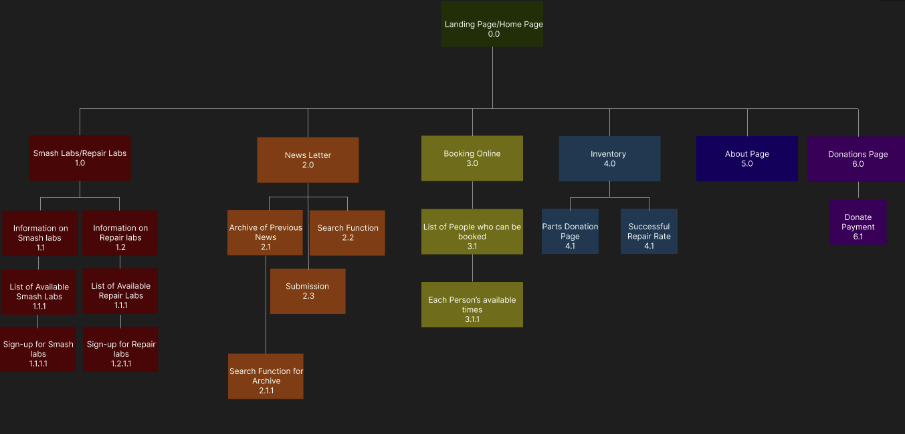
Low-Fidelity Prototypes
Landing Page: Bryanna, Mason
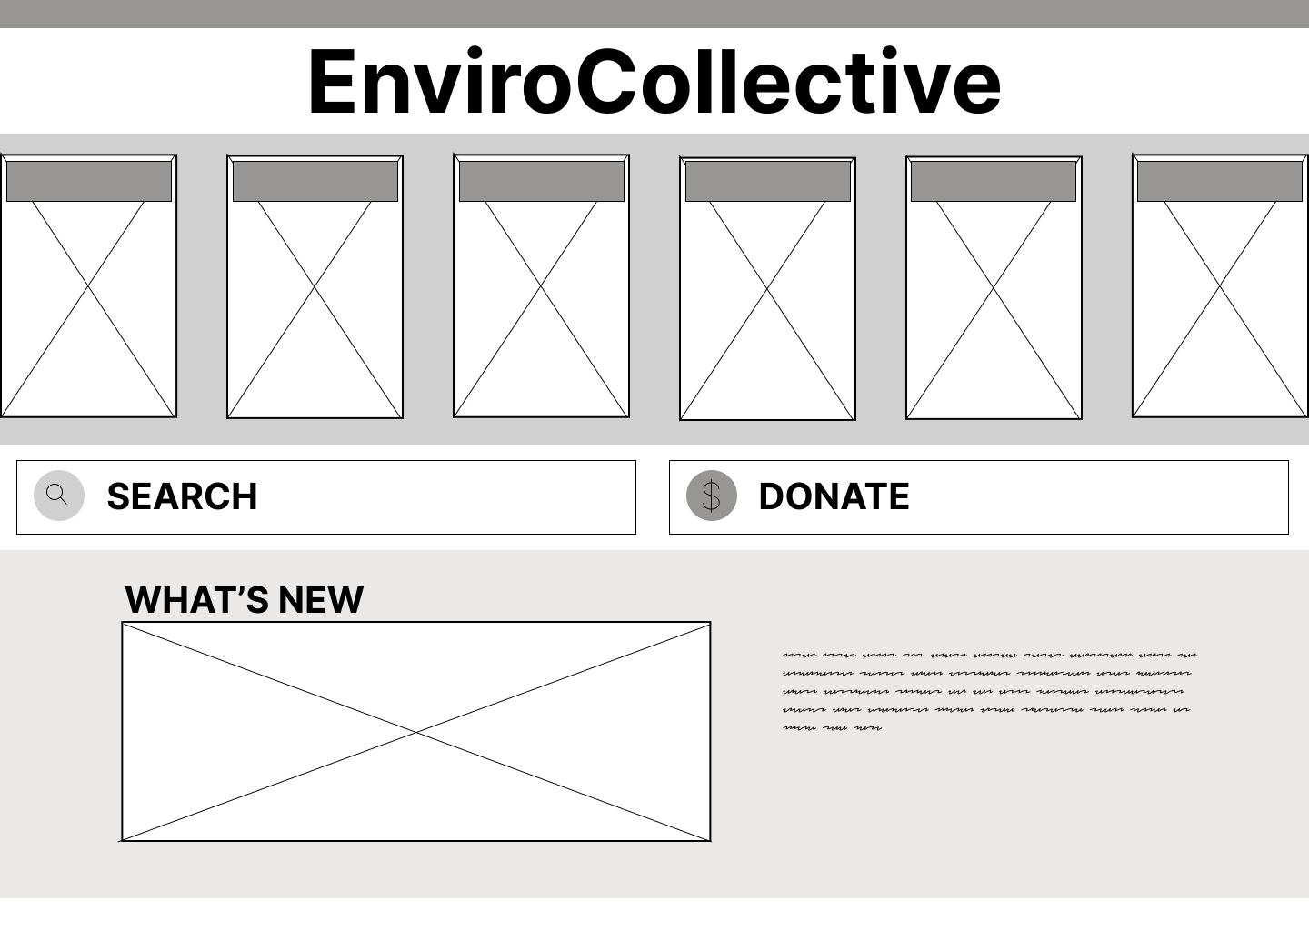
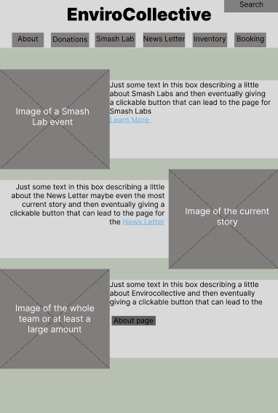
Lei-Ann
Booking Page
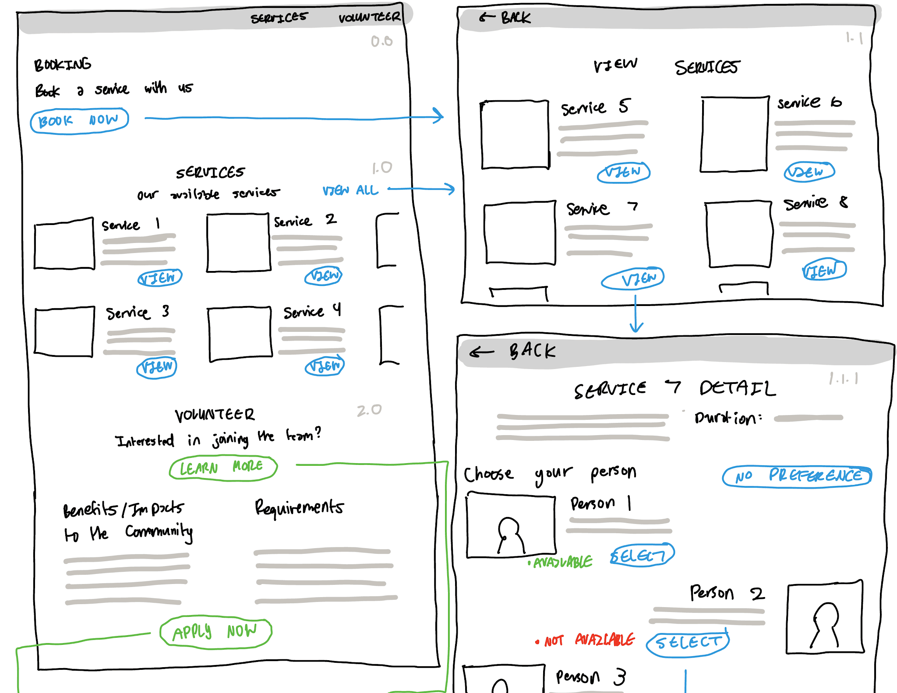
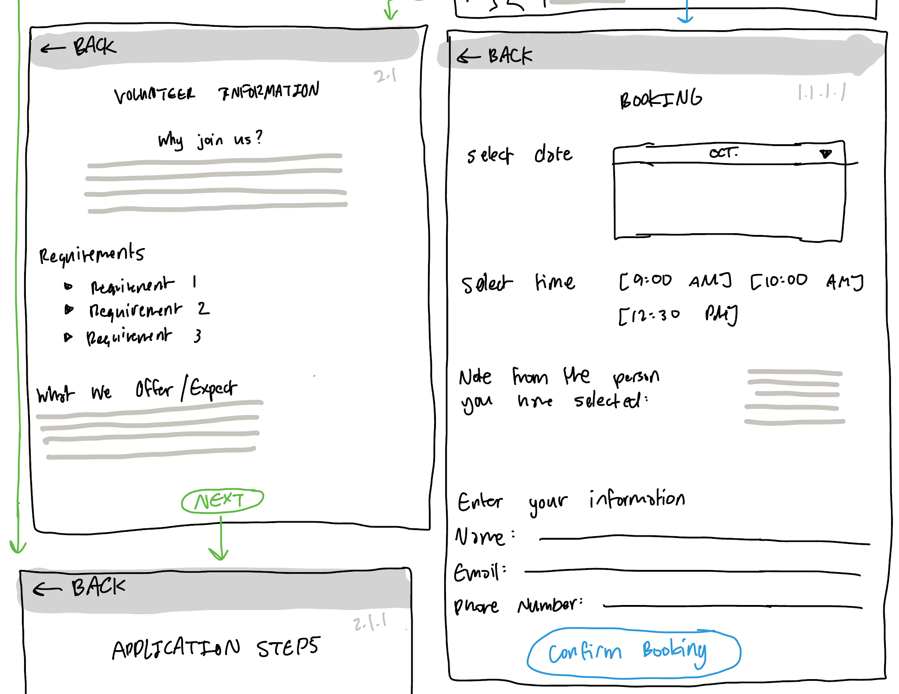
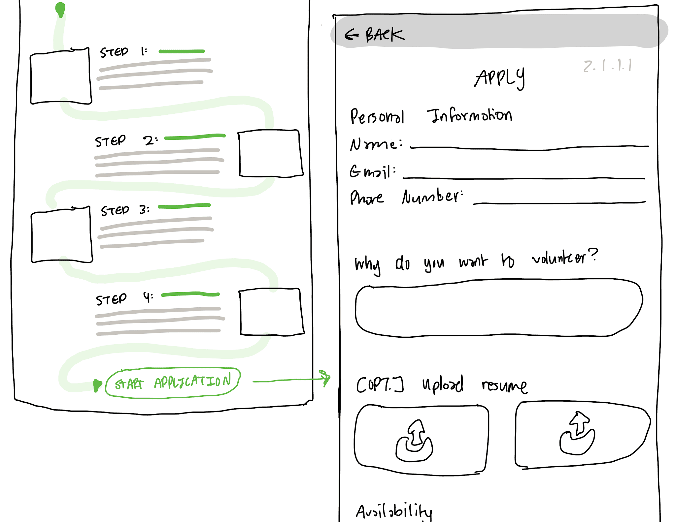
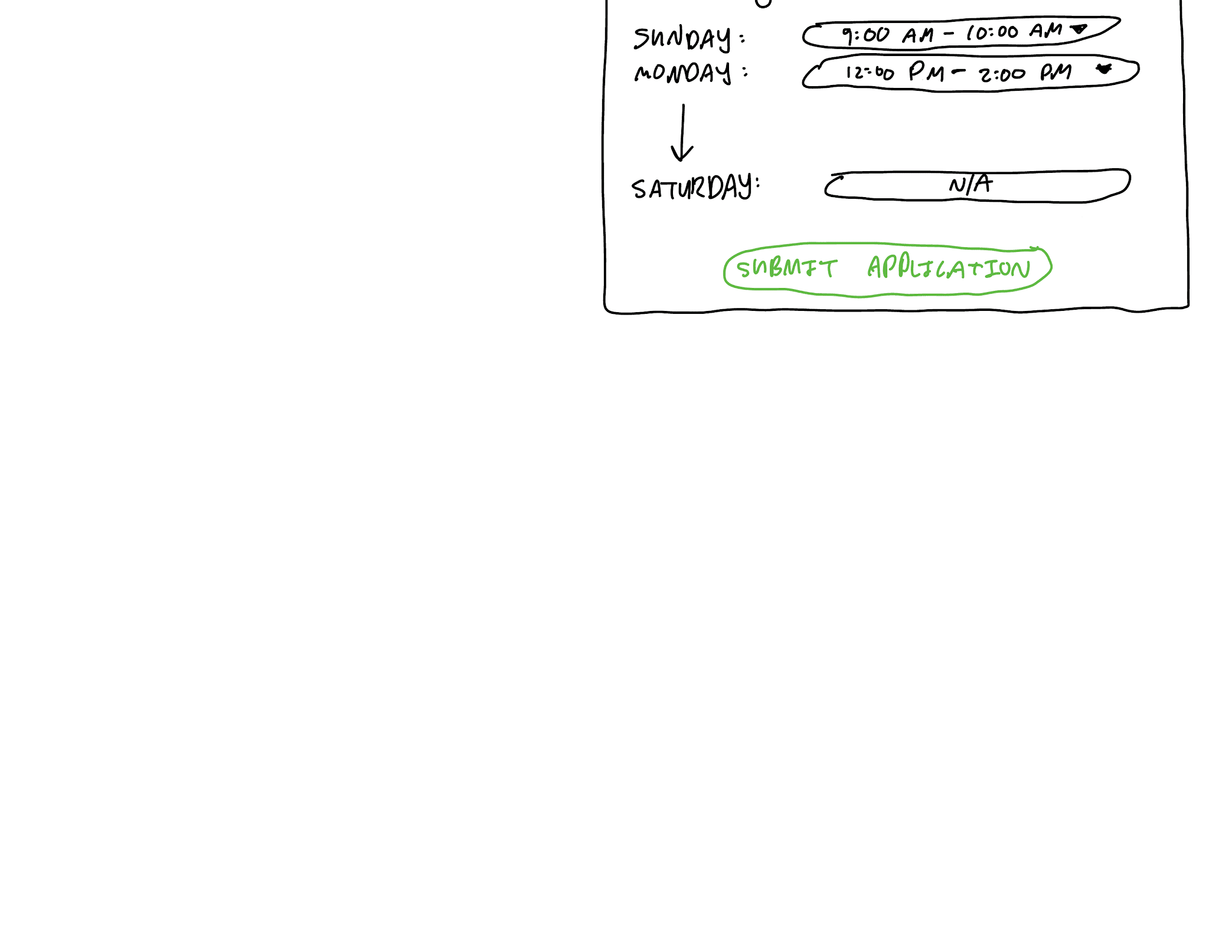
Admin Portal
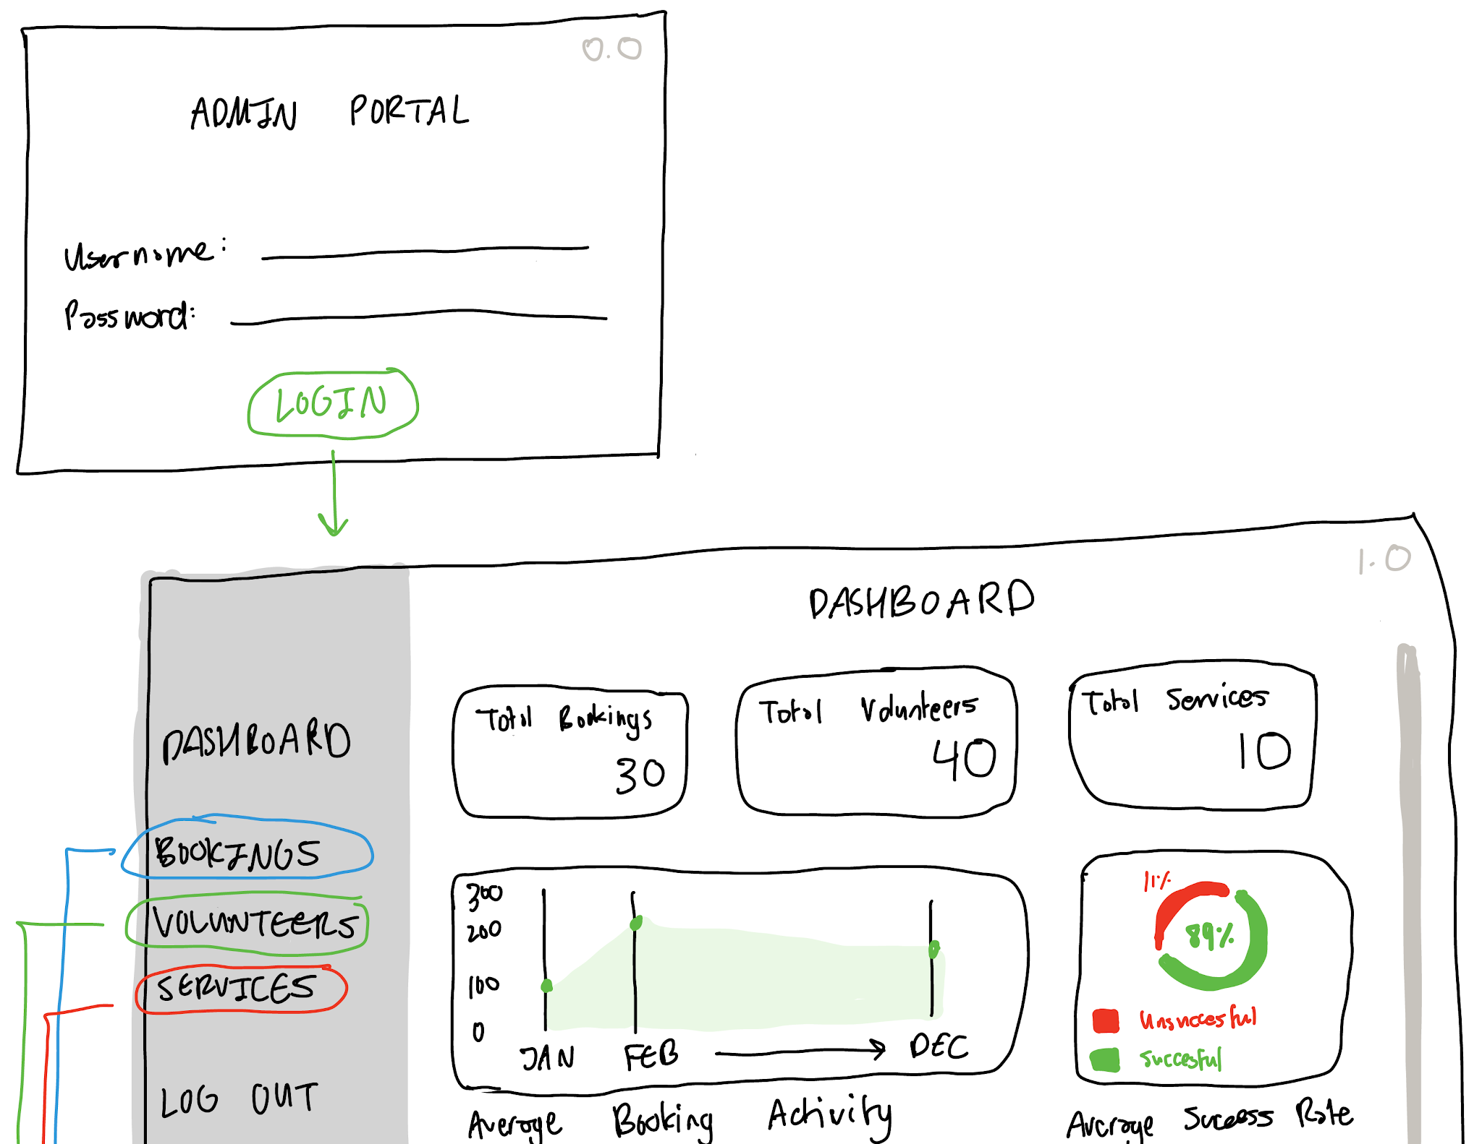
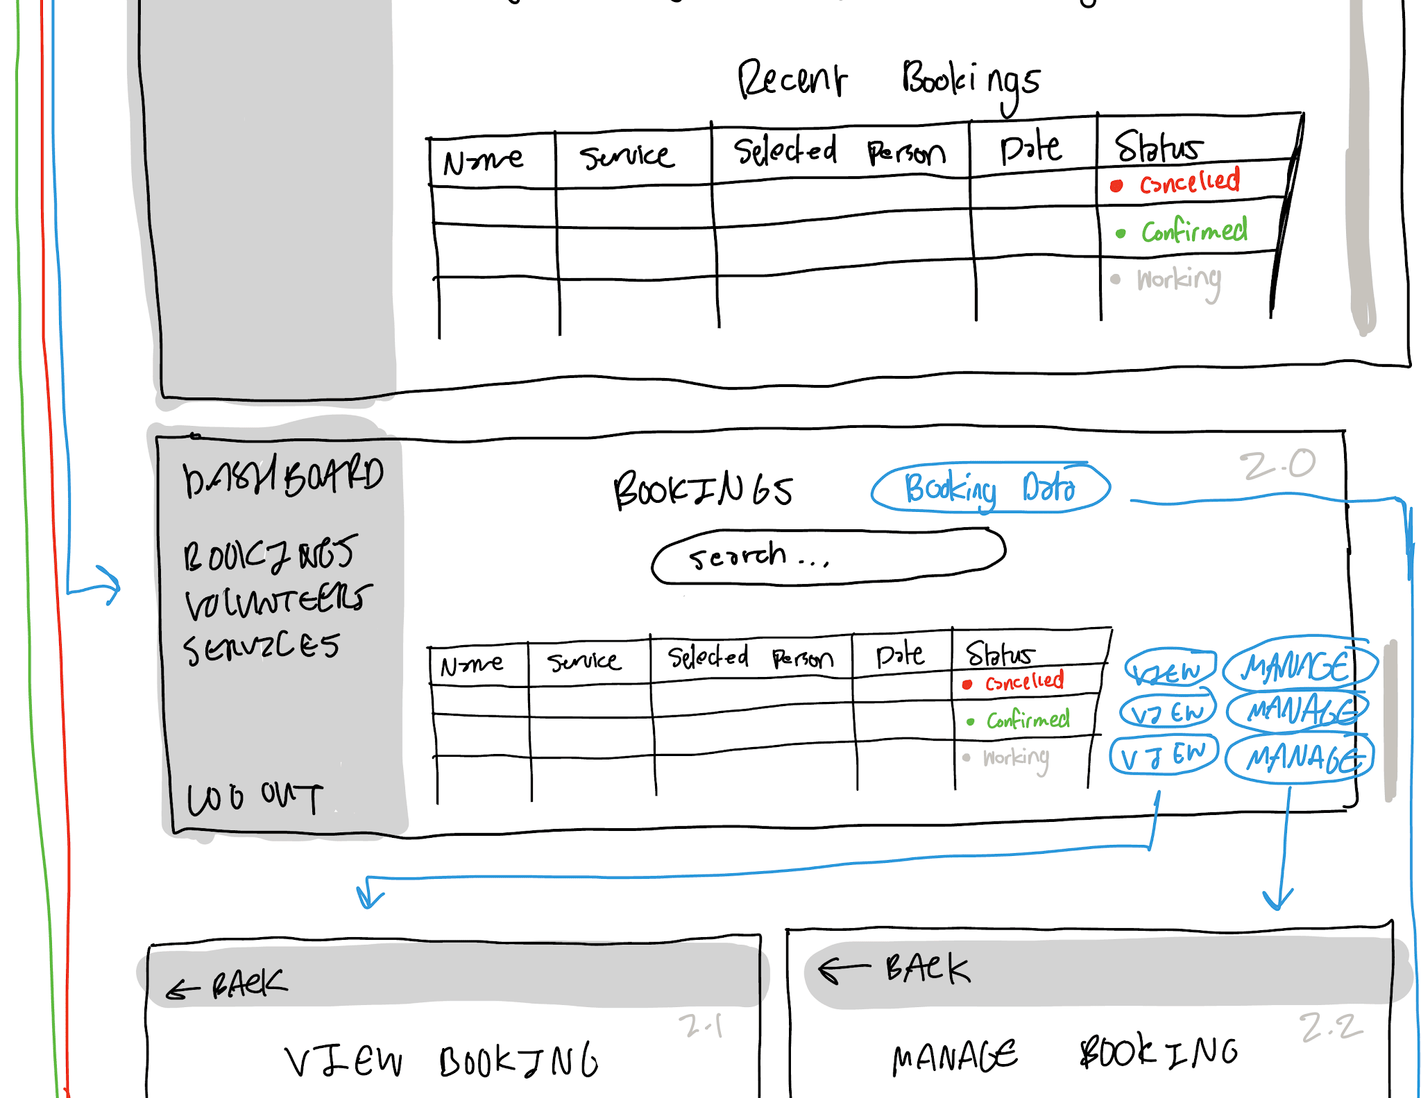
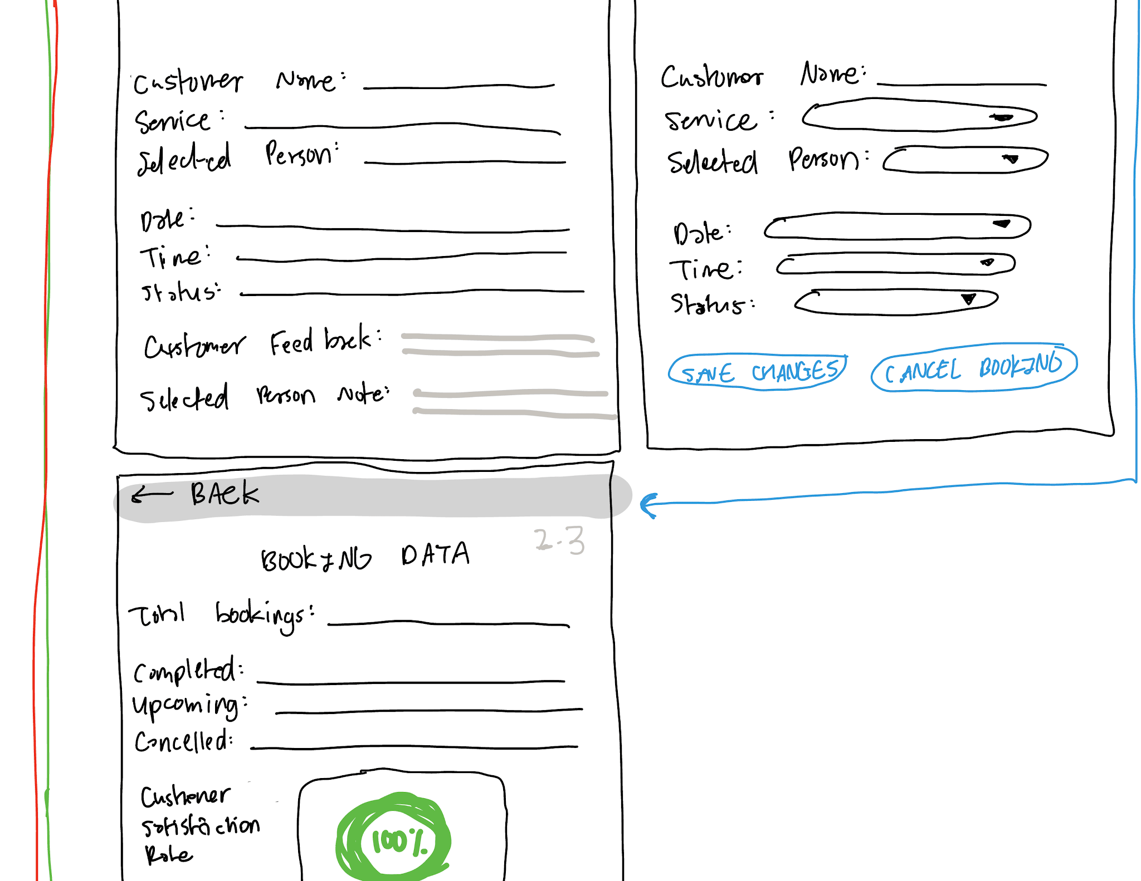
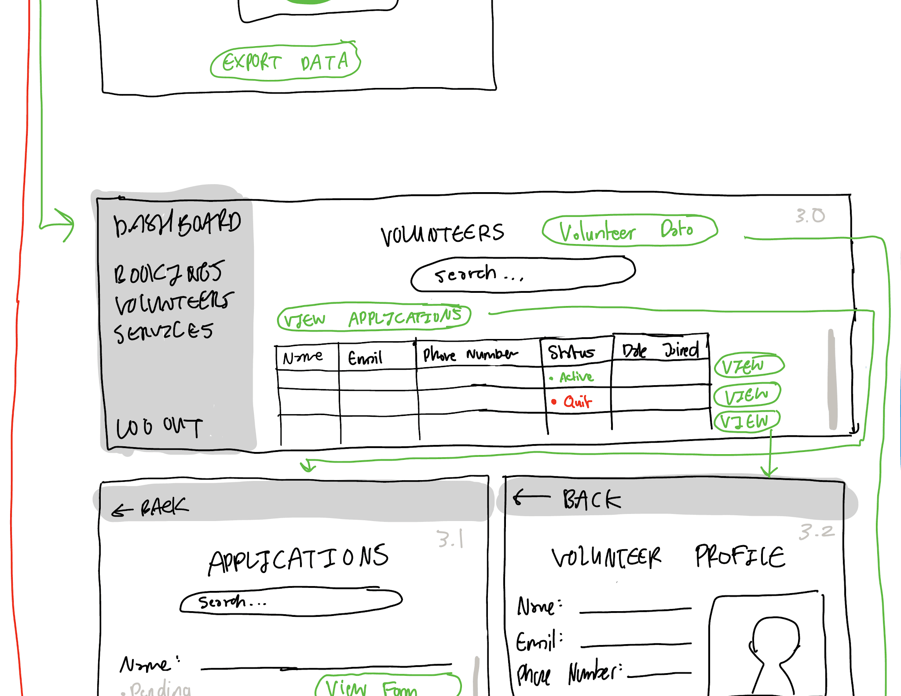
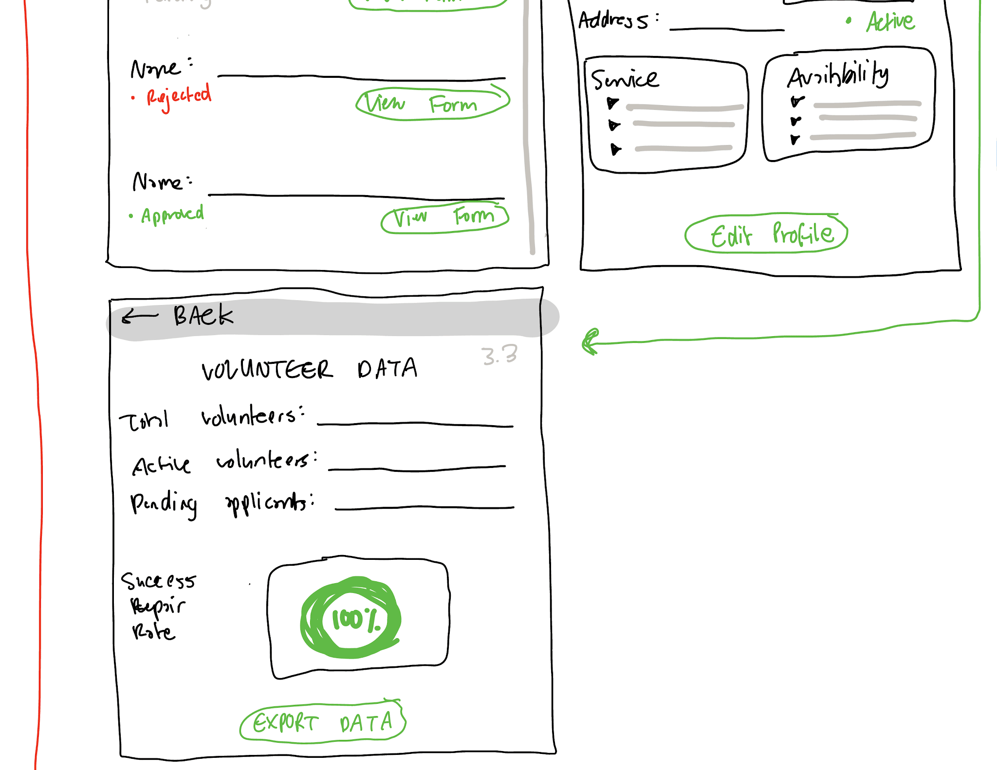

Audrey
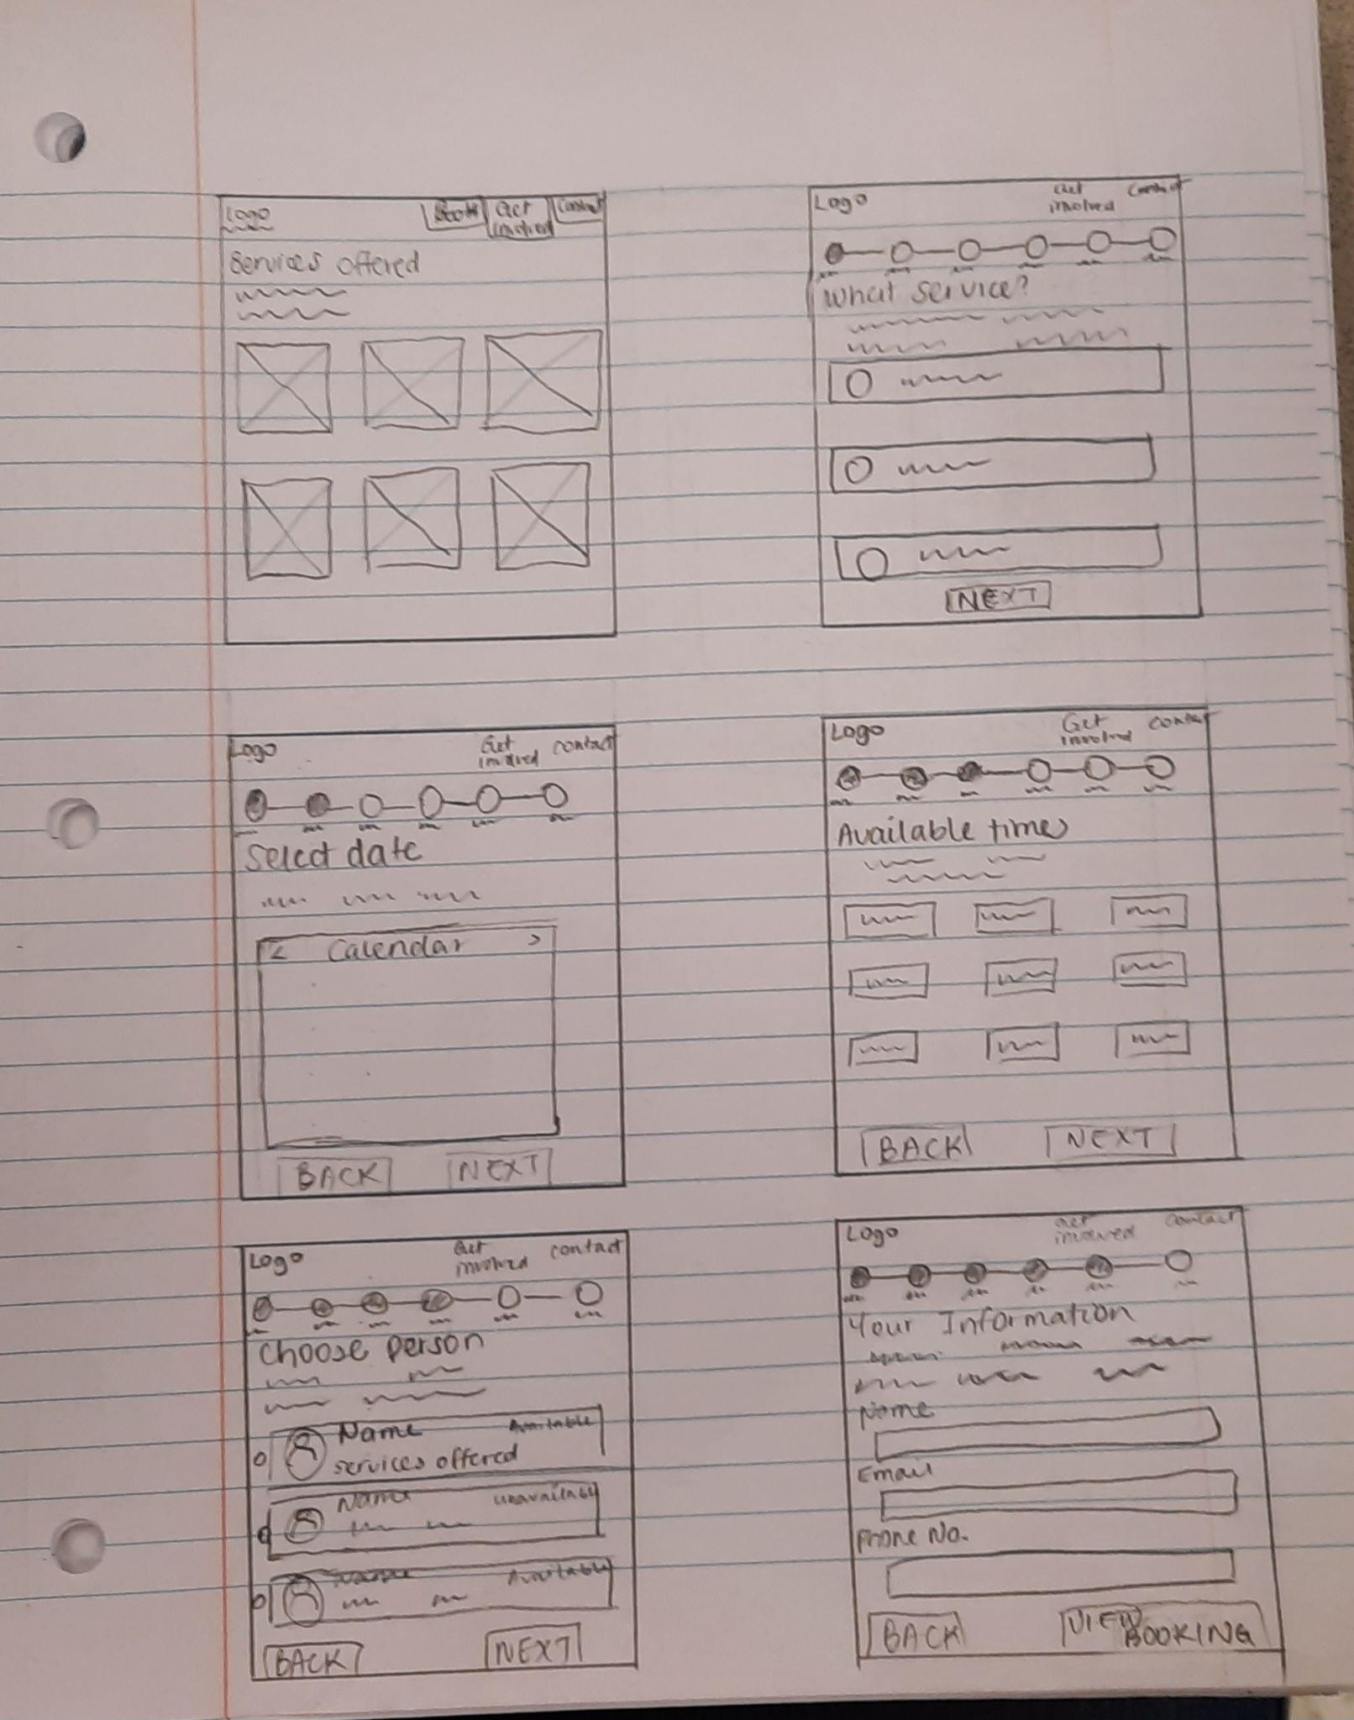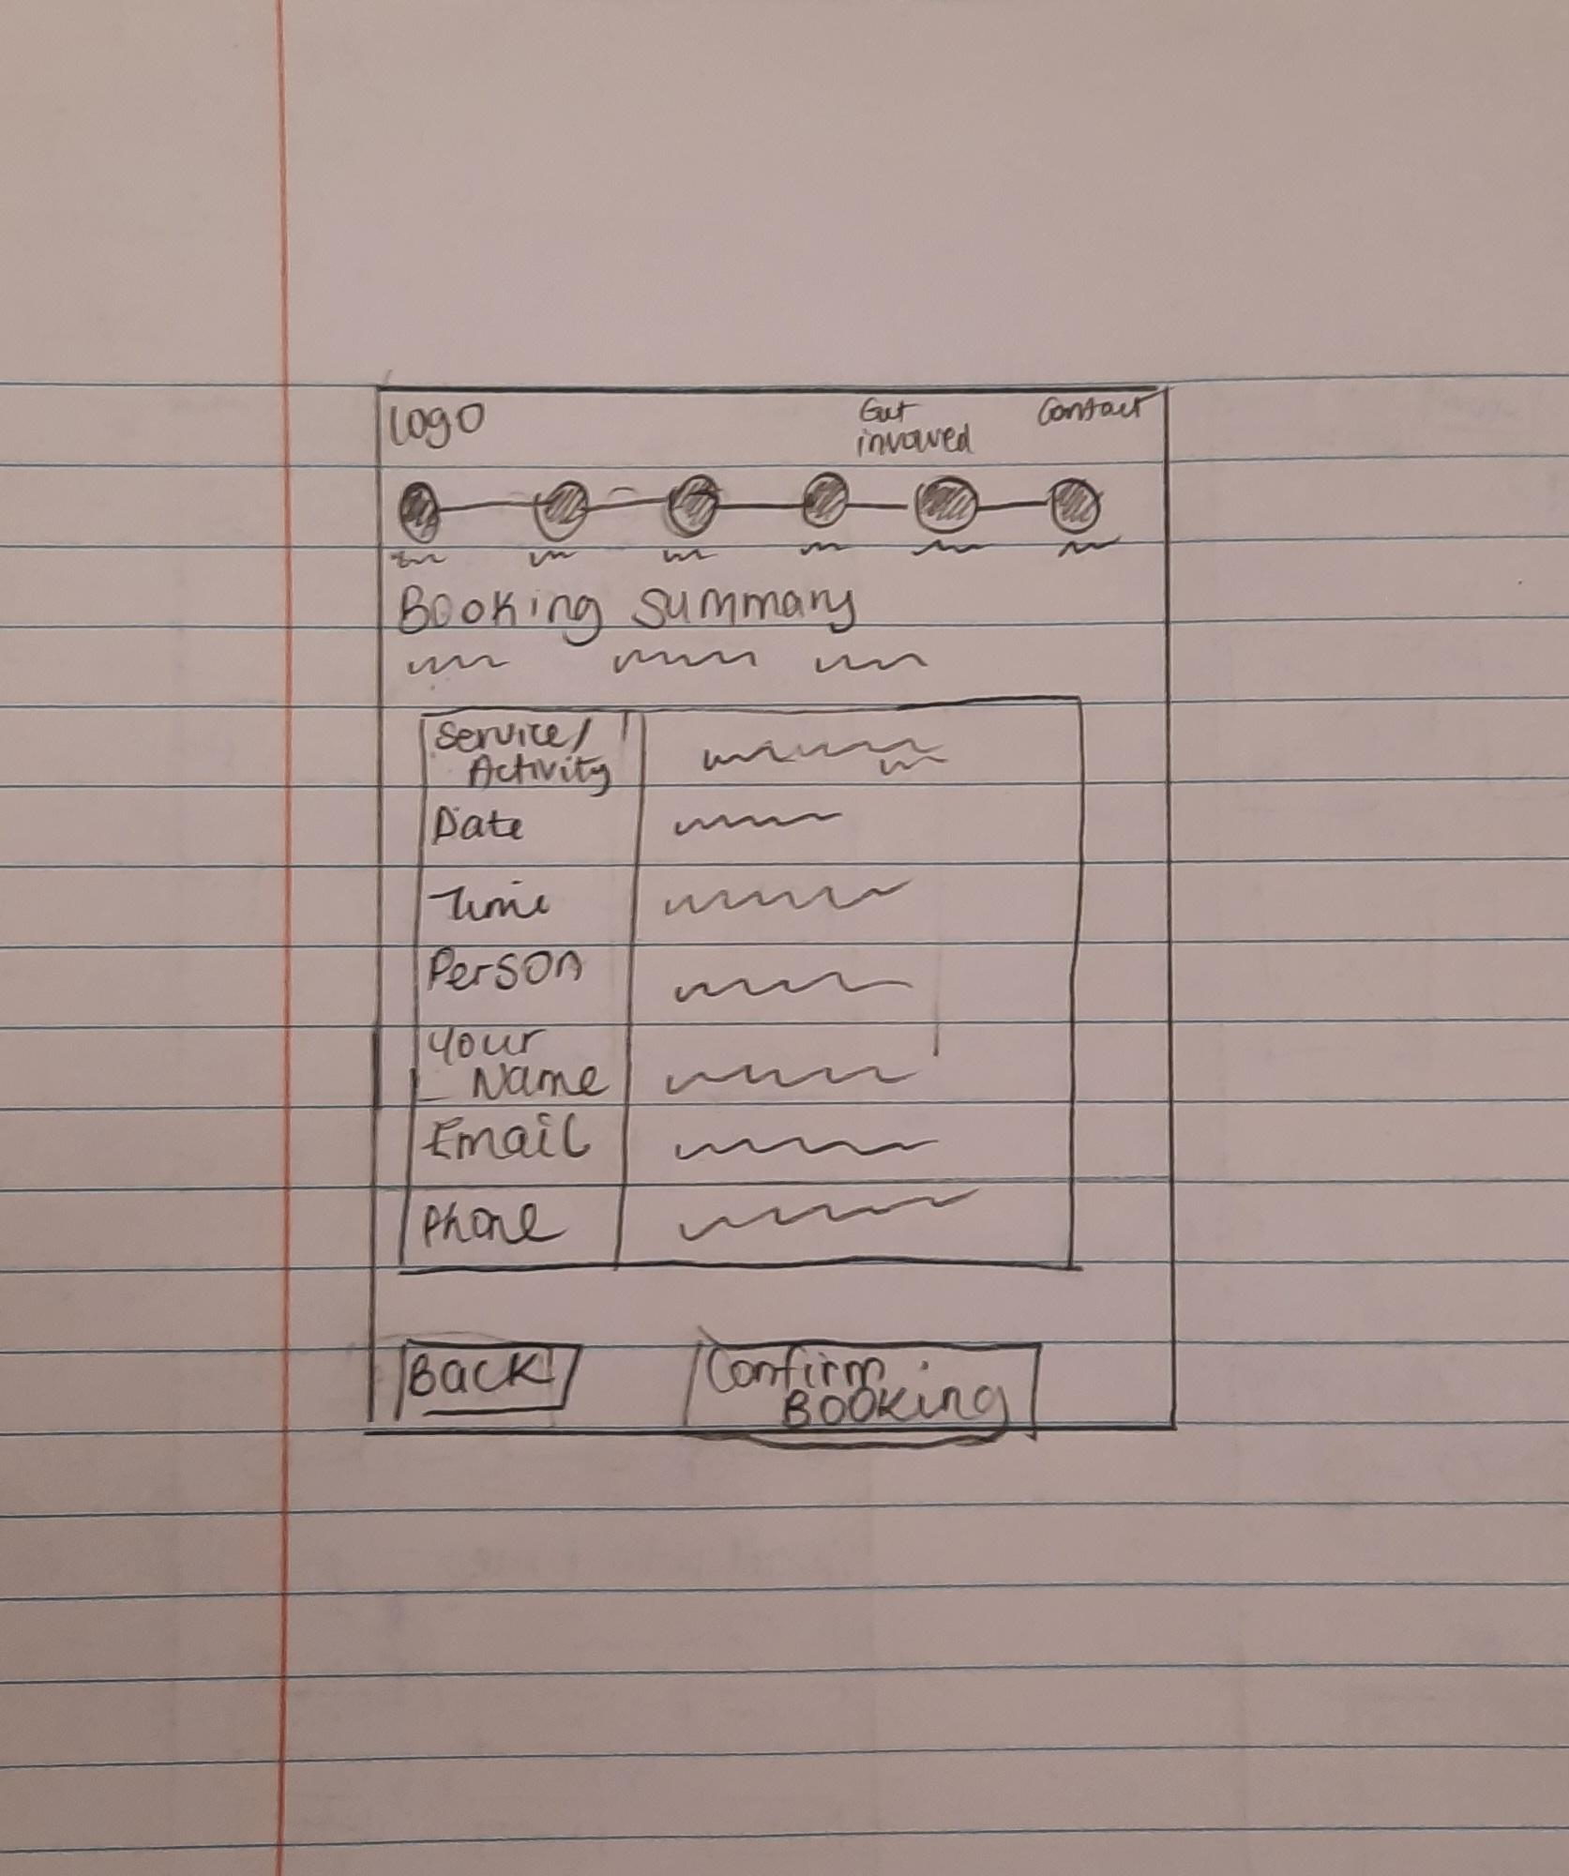

Questions: Was there anything that stood out in a negative way? What is something that you can see in the final website? Is there anything you would like us to consider moving forward?

